**Feasibility Analysis(Discussion Portal)**

**By Utkarsh Srivastava**

In order to acknowledge the feasibility of the software we did a survey of the members of the client University :

**What If the new system was not implemented???**

Ans) Currently the mailing system for reports about items being lost or found results in a large junk of mail in inbox of every member of the university. The highest authority gets bothered during any time of the day and also the method is very tedious. And because of such a large number of emails and reports usually people tend to ignore the mails.

Also for organizing events there is sometimes a clash between several events and authorities have to deal with the cases manually.

This new Method thus saves times and gives the mailing priority to more formal notices.

**What are the current process problems?**

The current process is time consuming and very clumsy which leads to increased bulk of mails in inbox.

As for event scheduling the discussion is manual and sometimes clashing leads to difficulty in organizing the event.

The current process is not User friendly, Robust, Adaptable

**How will the proposed system help??**

The new System will reduce the waste of time. Collect all event details and display at one place and reduce the mail junk. Will make the work of officials a less heavy. Hence making the working more efficient.

**Is new Technology Need What Skills??**

No new technology is needed, the software can be easily prepared by currently known technology.But the developers need skill set of web development and database design.

**What facilities must be supported by new System??**

The new Technology will be more user friendly,will be more efficient in comparison to previous one and also this technology is more adaptive and reduction of useless cases will take place.

Comparing The Current System and New System….. the responses were as follows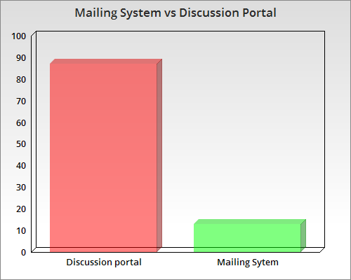

We asked them:

**On a scale of 5 how much would you like to give this idea:**

The response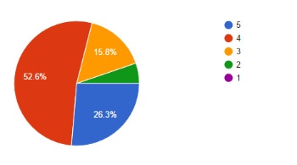

Also we asked them:

**Do you find this idea useful??**

The responses were: